REGISTRATION FORM

To be sent to: [info@sardiniacocs.it;chiara.lualdi@uniupo.it](mailto:info@sardiniacocs.it;chiara.lualdi@uniupo.it) along with **Bank receipt**

SURNAME:

NAME:

AFFILIATION:

INVOICE ADDRESS:

COUNTRY:

PHONE: E- MAIL:

VAT/FISCAL ID/CF:

HOTEL RESERVATION **(Villa Signorini or Hotel Herculaneum)**: n° _______________________________

CHECK-IN (dd/mm/yy): CHECK-OUT (dd/mm/yy):

|  |  |  |  |  |
| --- | --- | --- | --- | --- |
|  | **EARLY RATE DISCOUNTED\***  (by May 1st) | **EARLY RATE**  (by May 15) | **REGULAR RATE**  (by July 15) | **LATE RATE**  (from July 16th) |
|  |  |  |  |  |
| **SPEAKER**  **(academic/non-profit)** | 600 | 650 | 750 | 900 |
| **PhD and YOUNG RESEARCHER (<35 years)** | - | 450 | 500 | 550 |
| **DELEGATE** | - | 350 | 400 | 450 |
| **ACCOMPANYING** | - | 250 | 300 | 350 |
| **CORPORATE/INDUSTRY** |  |  | 1000 | 1200 |
| **RATE BY DAY**  **Speaker**  **Accompanying** |  |  | **250**  **100** | **300**  **120** |

**Registration fee includes** coffee breaks, Welcome Party, Lunches, Social dinner, Gala Dinner, Farewell Party; Excursion to Reggia di Portici.

Tax: Prices include 22% Italian VAT

**\* This rate applies to participants who have attended previous ICSC meetings**

**PAYMENT BY BANK TRANSFER to SARDINIA COCS SRL (see below bank details)**

DATE _________________________________________ SIGNATURE_____________________________

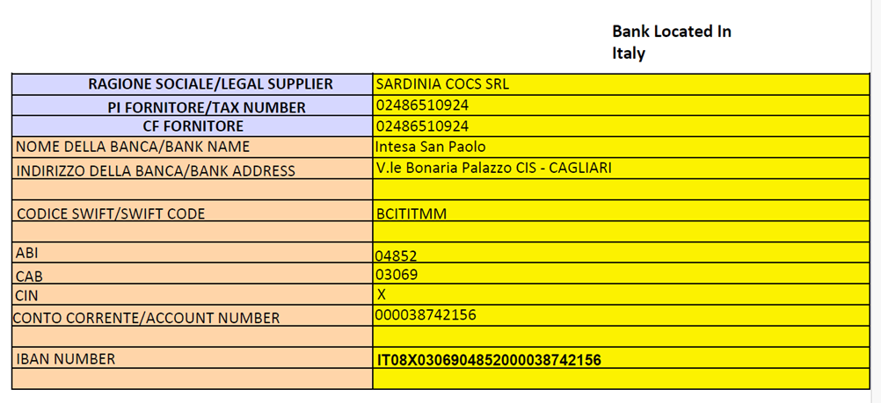

Any bank charges by local or intermediate bank must be borne by the remitter. Clearly indicate the name of the participant(s) and Congress registration number on the remittance slip/reference text.

**Cancellation policy** 80% refund if notified before July 15th; 50% refund if notified before Sept 15th; no refund if notified after Sept 16th.