ACCOMMODATION
(make your reservation asap; this period is still high season, and this location is very popular)

Villa Signorini https://www.villasignorini.it/ only a few rooms are available (first come, first served)
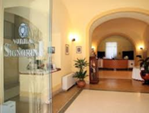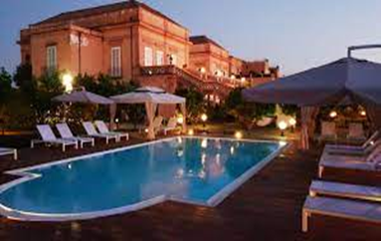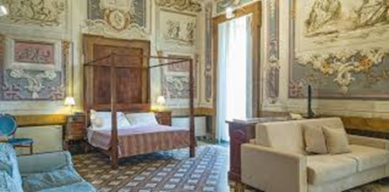

Hotel Herculaneum https://www.hotelherculaneum.com/ (3 stars, managed by Villa Signorini)
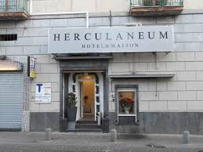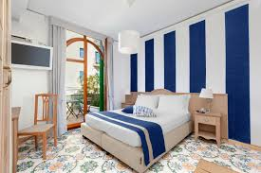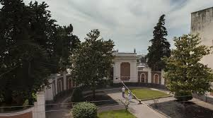 900 m from Conference venue
IMPORTANT NOTE
To take advantage of the discounted rate, use the following link
Villa Signorini Events & Hotel
Herculaneum Hotel & Maison
and enter the code ICSC25

Other options in the near (check on the web): Scognamiglio Suites; Villa Cua; Il Giardino dei Glicini; Hotel Souvenir; B&B Fuocomuorto.

